 | Cat.6 U/UTP 4P PVC-Eca
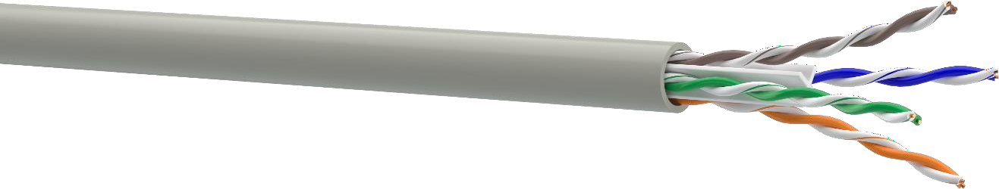
DESIGN  - Conductor: Solid annealed copper  - Insulation: HDPE  - Pair: two conductors twisted together Color identification of pairs:  - pair 1: white-blue / blue  - pair 2: white-orange / orange  - pair 3: white-green / green  - pair 4: white-brown / brown  - Cross-web: HDPE, 2,6x2,6 mm  - Sheath: PVC, nominal thickness 0,5 mm | 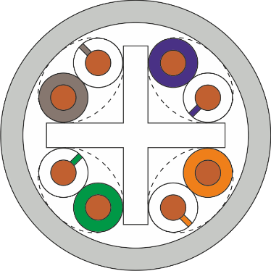
APPLICATION  PBX, V.11, X.21, ISDN, Ethernet (10Base-T), ATM-25/52/155 Mbit/s,  100VG-AnyLAN, Token Ring 16/100 Mbit/s, Fast Ethernet (100BASE- TX), 1000BASE-T, 2.5GBASE-T, 5GBASE-T, PoE, PoE+, PoE++ | INSTALLATION AND OPERATION CONDITIONS  For stationary installation inside buildings, stations, structures and equipment. Op- erated on frequencies up to 250 MHz
STANDARDS  Cabling: ISO/IEC 11801-1, EN 50173-1, ANSI/TIA-568.2-D  Cable: IEC 61156-5, EN 50288-6-1, ANSI/TIA-568.2-D  Fire safety:  - Flame propagation: EN 60332-1-2 CPR class: Eca | MECHANICAL CHARACTERISTICS  Temperature range:  - During installation -10 °C ... +60 °C  - After installation -20 °C ... +60 °C  Bending radius:  - During installation ≥ 8 cable diameters  - After installation ≥ 4 cable diameters Tensile stress ≤ 85 N

ELECTRICAL CHARACTERISTICS AT 20 °C
Parameter | Unit | Value
Capacitance | pF/m | ≤ 56
Resistance for conductor Ø, mm:  - 0,54 | Оhm/km | ≤ 82
Insulation resistance | GOhm*km | ≥ 5
Resistance unbalance | % | 1
Velocity of propagation (NVP) | % | 70
Propagation delay | ns/100 m | ≤ 534+36/√f
Delay skew | ns/100 m | ≤ 20
Characteristic impedance in the frequency range of:  - 1-100 MHz  - 101-250 MHz | Ohm | 100±15  100±22
Test voltage between cores, (DC, 2 s) | kV | 2,5

Frequency, MHz | 1 | 4 | 10 | 16 | 20 | 31,25 | 62,5 | 100 | 250
Attenuation, dB, max | 2,1 | 3,8 | 6 | 7,6 | 8,5 | 10,8 | 15,5 | 19,9 | 33
NEXT, dB, min | 75,3 | 66,3 | 60,3 | 57,3 | 55,8 | 52,8 | 48,3 | 45,3 | 39,3
PS NEXT, dB, min | 72,3 | 63,3 | 57,3 | 54,3 | 52,8 | 49,8 | 45,3 | 42,3 | 36,3
ELFEXT, dB, min | 68 | 56 | 48 | 44 | 42 | 38 | 32 | 28 | 20
PS ELFEXT, dB, min | 65 | 53 | 45 | 41 | 39 | 35 | 29 | 25 | 17
RL, dB, min | 20,0 | 23,0 | 25,0 | 25,0 | 25,0 | 23,6 | 21,5 | 20,1 | 17,3
IEC 61156-5, values lower than 4 MHz are given for information only

ORDER INFORMATION
P/N | Cable name | Nominal conductor  Ø, mm | Nominal insulation  Ø, mm | Estimated  сable Ø,  mm | Standard packaging | Weight, kg/km
49205 | KPV-VP (250) 4*2*0,54 (U/UTP-cat.6) | 0,54 | 0,98 | 5,745 | Cardboard box  305 m | 35,8

